重 庆 大 学

学 生 实 验 报 告

实验课程名称 JAVA EE程序设计

开课实验室 DS1511

学 院 大数据与软件学院 年级 2021 专业班 人工智能班

学 生 姓 名 余绵阳 学 号 20214579

开 课 时 间 2022 至 2023 学年第 2 学期

成 绩
教师签名

大数据与软件学院制

《JAVA EE程序设计》实验报告

开课实验室：DS1511 2023 年 3 月 26 日
学院 |  | 大数据与软件学院 | 年级、专业、班 |  | 21级人工智能1班 | 姓名 | 余绵阳 |  | 成绩
课程  名称 |  | JAVA EE程序设计 |  | 实验项目  名 称 | 实验7-8: 事件编程、数据库应用编程。 |  |  | 指导教师
教师评 | 教师签名：  2021年 月 日
- 实验目的
实验七：基本掌握使用JAVA来完成基本的图形界面等调试与编程，事件编程调试。
实验八：掌握利用JAVA完成数据库课程中的基本数据记录操作。

二、实验内容

实验内容：（二选一，提交该部分实验报告内容）
- 利用图形界面编程，实现C/S模式的数据库访问操作。完成SQL SERVER或MYSQL数据库管理系统的安装，配置，JAVA数据库访问环境的配置；完成数据库表的建立，记录插入等；建立用户表，包含用户名、密码字段；利用JAVA实现图形界面，用户登录验证，进入软件运行后，针对某表记录的增、删、改、查操作。
- 完成JAVA WEB应用开发，实现B/S模式的数据库访问操作。完成SQL SERVER或MYSQL数据库管理系统的安装，配置，JAVA数据库访问环境的配置，Tomcat服务器安装配置；完成数据库表的建立，记录插入等；建立用户表，包含用户名、密码字段；利用JAVA实现WEB应用，通过浏览器访问WEB进行用户登录验证，进入WEB应用运行后，针对某表记录的增、删、改、查操作。

三、使用仪器、材料
JAVA SE JDK 1.8.121
Tomcat
Mysql/Sql server

四、实验过程原始记录(数据、图表、计算等)：
该次实验内容由小组多人共同完成，以下是小组成员：（独立完成的只填本人）

学号 | 姓名 | 角色 | 任务 | 按照贡献排序
20214579 | 余绵阳 | 六边形战士 | 全部 | 100%

本项目通过java图形界面编程并通过MySQL的连接实现了银行ATM系统，主要实现的功能为用户界面的用户验证、注册开卡、余额查询、账户转账、密码修改、用户存款、退卡操作。
运行结果：
- 初始数据库数据集
Account user
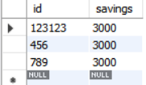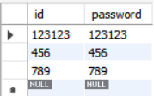
- 用户登入界面验证
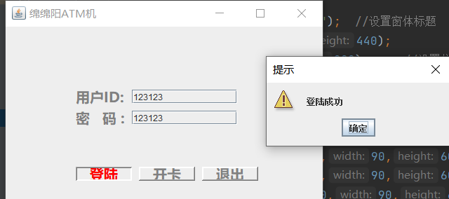
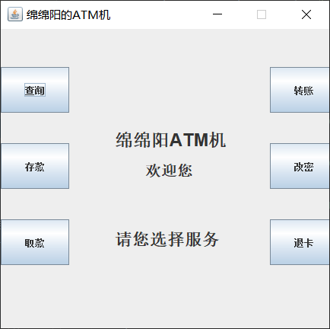
- 查询
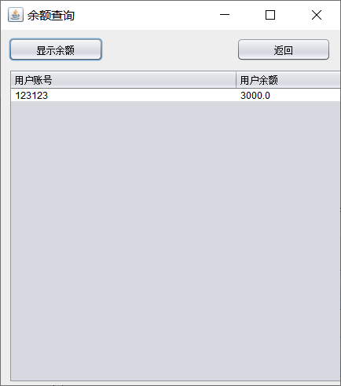
- 存款
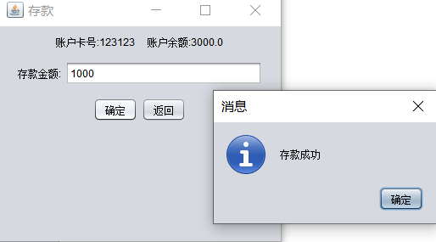
- 取款
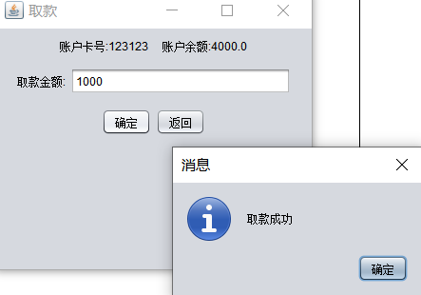
- 转账
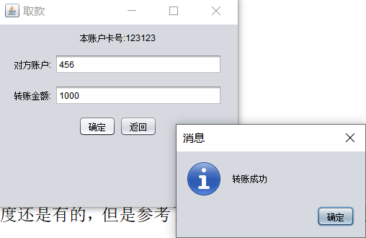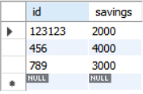
- 修改密码
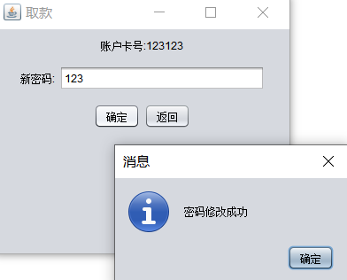
- 退卡
退出了
核心代码：
- 用户登入界面
package ui;
import java.awt.Color;
import java.awt.Font;
import java.awt.Graphics;
import java.awt.Image;
import java.awt.event.*;
import java.io.File;
import java.io.IOException;
import javax.imageio.ImageIO;
import javax.swing.*;
import dates.DBOperation;
import dates.MySqlConnection;

public class Window implements MouseListener {

public JFrame frame = new JFrame("绵绵阳ATM机");
private JLabel label1=new JLabel("用户ID:");
private JTextField txt1=new JTextField();
private JLabel label2=new JLabel("密 码 :");
private JTextField txt2=new JTextField();
private JButton btn1=new JButton("登陆");
private JButton btn2=new JButton("开卡");
private JButton btn3=new JButton("退出");
private String text1; //记录账号
private String text2; //记录密码
private int distinguish;//用来记录鼠标悬停在哪个位置
MySqlConnection myDB=new MySqlConnection();
public DBOperation myOpr=new DBOperation(myDB);
public Window(){

}

public void show(){
frame.setLayout(null);//定义空布局
frame.setSize(470,300);
frame.setLocation(400, 200);

Font font=new Font("微软雅黑",Font.BOLD,20);
label1.setFont(font);
label1.setForeground(Color.gray);//设置字体颜色
label2.setFont(font);

label2.setForeground(Color.gray);
txt1.setOpaque(false);//设置文本框透明
txt2.setOpaque(false);

btn1.setContentAreaFilled(false);//设置button组件透明
btn1.setFont(font);
btn1.setForeground(Color.gray);
btn1.setBorder(BorderFactory.createRaisedBevelBorder());//设置突出button组件
btn2.setContentAreaFilled(false);
btn2.setFont(font);
btn2.setBorder(BorderFactory.createRaisedBevelBorder());
btn2.setForeground(Color.gray);
btn3.setContentAreaFilled(false);
btn3.setFont(font);
btn3.setBorder(BorderFactory.createRaisedBevelBorder());
btn3.setForeground(Color.gray);

label1.setBounds(100,50,100,100);
txt1.setBounds(180,90, 150, 20);
label2.setBounds(100,80,100,100);
txt2.setBounds(180,120, 150, 20);
btn1.setBounds(100,200,80,20);
btn2.setBounds(190,200,80,20);
btn3.setBounds(280,200,80,20);
frame.setLayout(null);
frame.add(label1);
frame.add(txt1);
frame.add(label2);
frame.add(txt2);
frame.add(btn1);
frame.add(btn2);
frame.add(btn3);
btn1.addMouseListener(this);//添加鼠标监听
btn2.addMouseListener(this);
btn3.addMouseListener(this);
frame.setVisible(true);
}

public void mouseClicked(MouseEvent arg0) {
text1=txt1.getText();//获取用户输入数据
text2=txt2.getText();
if(distinguish==1){
if(myOpr.selectName(text1)){//登录判断
if(myOpr.selectPassword(text2)){
JOptionPane.showMessageDialog(null, "登陆成功","提示",2);
Menu menu=new Menu(text1);
menu.id=text1;
txt1.setText("");
txt2.setText("");
distinguish=4;
frame.setVisible(false);//登录成功则关闭界面
}else{
JOptionPane.showMessageDialog(null, "密码错误","提示",2);
txt2.setText("");
myOpr.setNumber1();//密码错误将number置0
myOpr.setNumber2();
}
}else{
JOptionPane.showMessageDialog(null, "此id不存在，请开卡","提示",2);
txt1.setText("");
txt2.setText("");
}
}
if(distinguish==2){

String logi=(String) JOptionPane.showInputDialog(null,"请输入你的id：\n","开卡",JOptionPane.PLAIN_MESSAGE,null,null,"");
String pas=(String) JOptionPane.showInputDialog(null,"请输入你的密码：\n","开卡",JOptionPane.PLAIN_MESSAGE,null,null,"");
myOpr.insertData(logi,pas);
JOptionPane.showMessageDialog(null, "开卡成功","提示",2);
}
if(distinguish==3){
int n = JOptionPane.showConfirmDialog(null, "是否退出?", "退出",JOptionPane.YES_NO_OPTION);
myDB.closeMySqlConnection();
if(n==JOptionPane.YES_OPTION){
System.exit(1);
}
}

}

public void mouseEntered(MouseEvent arg0) {
if (arg0.getSource() == btn1) {
distinguish=1;//鼠标悬停在btn1处则把distinguish置1
btn1.setForeground(Color.red);//改变颜色
btn1.setBorder(BorderFactory.createLoweredBevelBorder());//组件凹陷
btn2.setForeground(Color.gray);
btn2.setBorder(BorderFactory.createRaisedBevelBorder());
btn3.setForeground(Color.gray);
btn3.setBorder(BorderFactory.createRaisedBevelBorder());
}
if (arg0.getSource() == btn2) {
distinguish=2;
btn1.setForeground(Color.gray);
btn1.setBorder(BorderFactory.createRaisedBevelBorder());
btn2.setForeground(Color.red);
btn2.setBorder(BorderFactory.createLoweredBevelBorder());
btn3.setForeground(Color.gray);
btn3.setBorder(BorderFactory.createRaisedBevelBorder());
}
if (arg0.getSource() == btn3) {
distinguish=3;
btn1.setForeground(Color.gray);
btn1.setBorder(BorderFactory.createRaisedBevelBorder());
btn2.setForeground(Color.gray);
btn2.setBorder(BorderFactory.createRaisedBevelBorder());
btn3.setForeground(Color.red);
btn3.setBorder(BorderFactory.createLoweredBevelBorder());
}

}
public void mouseExited(MouseEvent arg0) {//鼠标退出三个button组件后恢复
distinguish=0;
label1.setForeground(Color.gray);
label2.setForeground(Color.gray);
txt1.setOpaque(false);
txt2.setOpaque(false);
btn1.setContentAreaFilled(false);
btn1.setForeground(Color.gray);
btn1.setBorder(BorderFactory.createRaisedBevelBorder());
btn2.setContentAreaFilled(false);
btn2.setBorder(BorderFactory.createRaisedBevelBorder());
btn2.setForeground(Color.gray);
btn3.setContentAreaFilled(false);
btn3.setBorder(BorderFactory.createRaisedBevelBorder());
btn3.setForeground(Color.gray);
}

public void mousePressed(MouseEvent arg0) {

}
public void mouseReleased(MouseEvent arg0) {

}

}
- 菜单
package ui;

import java.awt.event.ActionEvent;
import java.awt.event.ActionListener;
import java.sql.*;

import javax.swing.*;
/**
*
* @author contentcl
* Menu是一个 菜单类，也是最为底层的一个类
* 提供各个功能的按钮
*
* 此类未使用布局， 所以使用坐标固定了各个标签和按钮的位置
*
*/

public class Menu extends JFrame implements ActionListener{

JButton jb1, jb2, jb3,jb4,jb5,jb6,jb7, jb8; //创建按钮
JLabel jlb1, jlb2, jlb3; //标签
public String id;
public float savings;
public Menu(String id)
{
try {
Class.forName("com.mysql.cj.jdbc.Driver");
String url = "jdbc:mysql://localhost:3306/test01";//注意设置时区
String username = "root";
String passwords = "123";
Connection conn = DriverManager.getConnection(url, username, passwords);
String sql = "select savings from account where id="+id;
PreparedStatement pstm = conn.prepareStatement(sql);
ResultSet rs = pstm.executeQuery();
while(rs.next()) {
savings=rs.getFloat("savings");
}
} catch (SQLException | ClassNotFoundException b) {
throw new RuntimeException(b);
}
jb1 = new JButton("查询");
jb2 = new JButton("存款");
jb3 = new JButton("取款");
jb4 = new JButton("转账");
jb5 = new JButton("改密");
jb6 = new JButton("退卡");

jlb1 = new JLabel("绵绵阳ATM机");
jlb1.setFont(new java.awt.Font("Dialog", 1, 23)); //设置字体类型， 是否加粗，字号
jlb2 = new JLabel("欢迎您");
jlb2.setFont(new java.awt.Font("Dialog", 1, 20));
jlb3 = new JLabel("请您选择服务");
jlb3.setFont(new java.awt.Font("Dialog", 1, 22));

jb1.addActionListener(this); //事件监听
jb2.addActionListener(this);
jb3.addActionListener(this);
jb4.addActionListener(this);
jb5.addActionListener(this);
jb6.addActionListener(this);

this.setTitle("绵绵阳的ATM机"); //设置窗体标题
this.setSize(450, 440); //设置窗体大小
this.setLocation(400, 200); //设置位置
this.setLayout(null); //设置布局，不采用布局

//设置按钮的位置和大小
jb1.setBounds( 0,50,90,60);
jb2.setBounds( 0,150,90,60);
jb3.setBounds( 0,250,90,60);
jb4.setBounds( 354,50,90,60);
jb5.setBounds( 354,150,90,60);
jb6.setBounds( 354,250,90,60);

//设置标签的位置和大小
jlb1.setBounds(150,120,150,50);
jlb2.setBounds(190,160,150,50);
jlb3.setBounds(150,250,150,50);

this.add(jb1); //加入窗体
this.add(jb2);
this.add(jb3);
this.add(jb4);
this.add(jb5);
this.add(jb6);
this.add(jlb1);
this.add(jlb2);
this.add(jlb3);

this.setDefaultCloseOperation(EXIT_ON_CLOSE); //设置可关闭

this.setVisible(true); //设置可见
this.setResizable(false); //设置不可拉伸大小
}

@Override
public void actionPerformed(ActionEvent e) {
// // TODO Auto-generated method stub
if (e.getActionCommand()=="查询")
{
//String order = e.getActionCommand();
Savings savings=new Savings();
savings.id=id;
dispose();

}
else if (e.getActionCommand()=="存款")
{

SaveMoney saveMoney=new SaveMoney(id,savings);

saveMoney.setId(id);
saveMoney.setSavings(savings);
dispose();

}
else if (e.getActionCommand()=="取款")
{
Withdrawal withdrawal=new Withdrawal(id,savings);
withdrawal.setId(id);
withdrawal.setSavings(savings);
dispose();

}
else if (e.getActionCommand()=="转账")
{
Transfer transfer=new Transfer(id);
transfer.setId(id);
transfer.setSavings(savings);
dispose();
}
else if (e.getActionCommand()=="改密")
{
ChangePassword changePassword=new ChangePassword(id);
changePassword.setId(id);
dispose();
}

else if (e.getActionCommand()=="退卡")
{
System.exit(0);;
}

}

}
- 余额查询
package ui;
import dates.DBOperation;
import dates.MySqlConnection;

import javax.swing.*;
import javax.swing.table.JTableHeader;
import java.awt.event.ActionEvent;
import java.awt.event.ActionListener;
import java.sql.*;

public class Savings extends JFrame {
private JScrollPane scpDemo;
public String id;
private JTableHeader jth;
private JTable tabDemo;
private JButton btnShow;
private JButton bt1;
private JButton bt2;
private JButton back;

{
try {
for (javax.swing.UIManager.LookAndFeelInfo info : javax.swing.UIManager.getInstalledLookAndFeels()) {
if ("Nimbus".equals(info.getName())) {
javax.swing.UIManager.setLookAndFeel(info.getClassName());
break;
}
}
} catch (Exception e) {
System.out.println(e);
}
}

public Savings() {
super("余额查询"); //JFrame的标题名称
this.setSize(450, 500); //控制窗体大小
this.setLayout(null); //自定义布局
this.setLocation(400, 200); //点击运行以后，窗体在屏幕的位置
this.scpDemo = new JScrollPane();
this.bt1 = new JButton("确定");
this.bt2 = new JButton("取消");
this.back = new JButton("返回");
this.btnShow = new JButton("显示余额");
this.bt1.setBounds(100, 480, 100, 30);
this.bt2.setBounds(380, 480, 100, 30);
this.scpDemo.setBounds(10, 50, 580, 400); //设置滚动框大小
this.btnShow.setBounds(10, 10, 120, 30); //设置按钮
this.back.setBounds(300, 10, 120, 30); //设置按钮
this.btnShow.addActionListener(new ActionListener() //给“显示数据”按钮添加事件响应。
{
public void actionPerformed(ActionEvent ae) {
btnShow_ActionPerformed(ae);
}
});
/********按钮“确定”的响应*******/
this.bt1.addActionListener(new ActionListener() {
@Override
public void actionPerformed(ActionEvent e) {
System.exit(0);
}
});
/******按钮 “取消”的响应*****/
this.bt2.addActionListener(new ActionListener() {
@Override
public void actionPerformed(ActionEvent e) {
System.exit(0);
}
});

this.back.addActionListener(new ActionListener() //给“back”按钮添加事件响应。
{
public void actionPerformed(ActionEvent ae) {
Menu menu=new Menu(id);
menu.id=id;
dispose();
}
});

/******* 将组件加入到窗体中******/
add(this.scpDemo);
add(this.back);

add(this.btnShow);
add(this.bt1);
add(this.bt2);
this.setVisible(true);
this.setDefaultCloseOperation(EXIT_ON_CLOSE);
}

public static void main(String[] args) {
new Savings();
}

/***连接数据库并显示到表格中***/
public void btnShow_ActionPerformed(ActionEvent ae) {
try {
Class.forName("com.mysql.cj.jdbc.Driver");
String url = "jdbc:mysql://localhost:3306/test01";//注意设置时区
String username = "root";
String passwords = "123";
Connection conn = DriverManager.getConnection(url, username, passwords);
String sql = "select * from account where id="+id;
PreparedStatement pstm = conn.prepareStatement(sql);
ResultSet rs = pstm.executeQuery();
int count = 0;
while (rs.next()) {
count++;
}
rs = pstm.executeQuery();
// 将查询获得的记录数据，转换成适合生成JTable的数据形式
Object[][] info = new Object[count][6];
String[] title = {"用户账号", "用户余额"};
count = 0;
while (rs.next()) {
info[count][0] = Integer.valueOf(rs.getInt("id"));
info[count][1] = rs.getString("savings");
count++;
}
// 创建JTable
this.tabDemo = new JTable(info, title);
// 显示表头
this.jth = this.tabDemo.getTableHeader();
// 将JTable加入到带滚动条的面板中
this.scpDemo.getViewport().add(tabDemo);
} catch (ClassNotFoundException cnfe) {
cnfe.printStackTrace();
JOptionPane.showMessageDialog(null, "数据源错误", "错误", JOptionPane.ERROR_MESSAGE);
} catch (SQLException sqle) {
sqle.printStackTrace();
JOptionPane.showMessageDialog(null, "数据操作错误", "错误", JOptionPane.ERROR_MESSAGE);
}
}
}
- 存款
package ui;
import java.awt.FlowLayout;
import java.awt.event.ActionEvent;
import java.awt.event.ActionListener;
import java.sql.*;
import javax.swing.*;

public class SaveMoney implements ActionListener{
public String id;
public float savings;
JTextField money;
JFrame frame;
JPanel jpanel_1,jpanel_2,jpanel_3,jpanel_4;
JButton button_enter,button_cancel;
JLabel yue;

public void setSavings(float savings){
this.savings=savings;
}
public void setId(String id1){
this.id=id1;

}
public SaveMoney (String id1,float savings1) {

frame=new JFrame("存款");

jpanel_1=new JPanel();
jpanel_1.add(new JLabel("账户卡号:"+id1));

jpanel_2=new JPanel();
yue=new JLabel("账户余额:"+savings1);
jpanel_2.add(yue);

jpanel_3=new JPanel();
jpanel_3.add(new JLabel("存款金额:"));
money=new JTextField(20);
jpanel_3.add(money);

jpanel_4=new JPanel();
button_enter=new JButton("确定");
jpanel_4.add(button_enter);
button_cancel=new JButton("返回");
jpanel_4.add(button_cancel);

frame.add(jpanel_1);
frame.add(jpanel_2);
frame.add(jpanel_3);
frame.add(jpanel_4);

frame.setLayout(new FlowLayout());
frame.setVisible(true);
frame.setBounds(500,500,350,300);
frame.setLocationRelativeTo(null);//在屏幕中间显示(居中显示)

button_enter.addActionListener(this);
button_cancel.addActionListener(this);
}

@Override
public void actionPerformed(ActionEvent e) {
if(e.getActionCommand().equals("确定"))//按下确定按钮
{

try {
if(!money.getText().equals("")){
String more =money.getText();
System.out.println(more);
try{
//调用Class.forName()方法加载驱动程序
Class.forName("com.mysql.cj.jdbc.Driver");
System.out.println("成功加载MySQL驱动！");

String url="jdbc:mysql://localhost:3306/test01"; //JDBC的URL
Connection conn;
conn = DriverManager.getConnection(url, "root","123");
Statement stmt = conn.createStatement(); //创建Statement对象
System.out.println("成功连接到数据库！");
//修改数据的代码
String sql2 = "update account set savings=savings+? where id=?";
PreparedStatement pst = conn.prepareStatement(sql2);
pst.setString(1,more);
pst.setString(2,id);
pst.executeUpdate();
stmt.close();
conn.close();
}catch(Exception c)
{
c.printStackTrace();
}

JOptionPane.showMessageDialog(null, "存款成功");//弹窗
money.setText("");//把存款金额清空
Menu menu=new Menu(id);
menu.id=id;
frame.dispose();
}
else
{
JOptionPane.showMessageDialog(null, "输入的存款金额不得为空");

}
}
catch (NumberFormatException e1)
{

JOptionPane.showMessageDialog(null, "输入数据类型错误，请输入整数");
money.setText("");//把存款金额清空
}
catch (Exception e1)
{
JOptionPane.showMessageDialog(null, e1.getMessage());
money.setText("");//把存款金额清空
}
}
else//按返回按钮
{
Menu menu=new Menu(id);
menu.id=id;
frame.dispose();
}

}

}

- 取款
package ui;
import java.awt.FlowLayout;
import java.awt.event.ActionEvent;
import java.awt.event.ActionListener;
import java.sql.*;
import javax.swing.*;

public class Withdrawal implements ActionListener{
public String id;
public float savings;
JTextField money;
JFrame frame;
JPanel jpanel_1,jpanel_2,jpanel_3,jpanel_4;
JButton button_enter,button_cancel;
JLabel yue;

public void setSavings(float savings){
this.savings=savings;
}
public void setId(String id1){
this.id=id1;

}
public Withdrawal (String id1,float savings1) {

frame=new JFrame("取款");

jpanel_1=new JPanel();
jpanel_1.add(new JLabel("账户卡号:"+id1));

jpanel_2=new JPanel();
yue=new JLabel("账户余额:"+savings1);
jpanel_2.add(yue);

jpanel_3=new JPanel();
jpanel_3.add(new JLabel("取款金额:"));
money=new JTextField(20);
jpanel_3.add(money);

jpanel_4=new JPanel();
button_enter=new JButton("确定");
jpanel_4.add(button_enter);
button_cancel=new JButton("返回");
jpanel_4.add(button_cancel);

frame.add(jpanel_1);
frame.add(jpanel_2);
frame.add(jpanel_3);
frame.add(jpanel_4);

frame.setLayout(new FlowLayout());
frame.setVisible(true);
frame.setBounds(500,500,350,300);
frame.setLocationRelativeTo(null);//在屏幕中间显示(居中显示)

button_enter.addActionListener(this);
button_cancel.addActionListener(this);
}

@Override
public void actionPerformed(ActionEvent e) {
if(e.getActionCommand().equals("确定"))//按下确定按钮
{

try {
if(!money.getText().equals("")){
String more =money.getText();
try{
//调用Class.forName()方法加载驱动程序
Class.forName("com.mysql.cj.jdbc.Driver");

String url="jdbc:mysql://localhost:3306/test01"; //JDBC的URL
Connection conn;
conn = DriverManager.getConnection(url, "root","123");
Statement stmt = conn.createStatement(); //创建Statement对象
//修改数据的代码
String sql2 = "update account set savings=savings-? where id=?";
PreparedStatement pst = conn.prepareStatement(sql2);
pst.setString(1,more);
pst.setString(2,id);
pst.executeUpdate();
stmt.close();
conn.close();
}catch(Exception c)
{
c.printStackTrace();
}

JOptionPane.showMessageDialog(null, "取款成功");//弹窗
money.setText("");//把存款金额清空
Menu menu=new Menu(id);
menu.id=id;
frame.dispose();
}
else
{
JOptionPane.showMessageDialog(null, "输入的存款金额不得为空");

}
}
catch (NumberFormatException e1)
{

JOptionPane.showMessageDialog(null, "输入数据类型错误，请输入整数");
money.setText("");//把存款金额清空
}
catch (Exception e1)
{
JOptionPane.showMessageDialog(null, e1.getMessage());
money.setText("");//把存款金额清空
}
}
else//按返回按钮
{
Menu menu=new Menu(id);
menu.id=id;
frame.dispose();
}

}

}
180 100.80 1.80
- 转账
package ui;
import java.awt.*;
import java.awt.event.ActionEvent;
import java.awt.event.ActionListener;
import java.sql.*;
import javax.swing.*;

public class Transfer implements ActionListener{
public String id;
public float savings;
JTextField money;
JTextField account;
JFrame frame;
JPanel jpanel_1,jpanel_2,jpanel_3,jpanel_4;
JButton button_enter,button_cancel;

public void setId(String id1){
this.id=id1;
}
public void setSavings(float savings){
this.savings=savings;
}
public Transfer (String id1) {

frame=new JFrame("取款");

jpanel_1=new JPanel();
jpanel_1.add(new JLabel("本账户卡号:"+id1));

jpanel_2=new JPanel();
jpanel_2.add(new JLabel("对方账户:"));
account=new JTextField(20);
jpanel_2.add(account);

jpanel_3=new JPanel();
jpanel_3.add(new JLabel("转账金额:"));
money=new JTextField(20);
jpanel_3.add(money);

jpanel_4=new JPanel();
button_enter=new JButton("确定");
jpanel_4.add(button_enter);
button_cancel=new JButton("返回");
jpanel_4.add(button_cancel);

frame.add(jpanel_1);
frame.add(jpanel_2);
frame.add(jpanel_3);
frame.add(jpanel_4);

frame.setLayout(new FlowLayout());
frame.setVisible(true);
frame.setBounds(500,500,350,300);
frame.setLocationRelativeTo(null);//在屏幕中间显示(居中显示)

button_enter.addActionListener(this);
button_cancel.addActionListener(this);
}

@Override
public void actionPerformed(ActionEvent e) {
if(e.getActionCommand().equals("确定"))//按下确定按钮
{
try {
if((!account.getText().equals(""))||(!money.getText().equals(""))){
String otherAccount =account.getText();
String transferMoney=money.getText();
try{
//调用Class.forName()方法加载驱动程序
Class.forName("com.mysql.cj.jdbc.Driver");
String url="jdbc:mysql://localhost:3306/test01"; //JDBC的URL
Connection conn;
conn = DriverManager.getConnection(url, "root","123");
Statement stmt = conn.createStatement(); //创建Statement对象
//修改数据的代码
if(savings-Float.parseFloat(transferMoney)>=0){
String sql1 = "update account set savings=savings-? where id=? ;" ;
String sql2 ="update account set savings=savings+? where id=? ;";
PreparedStatement pst1 = conn.prepareStatement(sql1);
PreparedStatement pst2 = conn.prepareStatement(sql2);
pst1.setString(1,transferMoney);
pst1.setString(2,id);
pst2.setString(1,transferMoney);
pst2.setString(2,otherAccount);
pst1.executeUpdate();
pst2.executeUpdate();
stmt.close();
conn.close();
JOptionPane.showMessageDialog(null, "转账成功");//弹窗
}
else {
JOptionPane.showMessageDialog(null, "余额不足");
}

}catch(Exception c)
{
c.printStackTrace();
}
account.setText("");
money.setText("");
Menu menu=new Menu(id);
menu.id=id;
frame.dispose();
}
else
{
JOptionPane.showMessageDialog(null, "账户和转账金额不为空");

}
} catch (HeadlessException ex) {
throw new RuntimeException(ex);
}
}
else//按返回按钮
{
Menu menu=new Menu(id);
menu.id=id;
frame.dispose();
}

}
public static void main(String [] args){
Transfer transfer=new Transfer("123123" );
transfer.setId("123123");
}
}

- 密码修改
package ui;
import java.awt.*;
import java.awt.event.ActionEvent;
import java.awt.event.ActionListener;
import java.sql.*;
import javax.swing.*;

public class ChangePassword implements ActionListener{
public String id;
JTextField newPassword;
JFrame frame;
JPanel jpanel_1,jpanel_2,jpanel_3,jpanel_4;
JButton button_enter,button_cancel;

public void setId(String id1){
this.id=id1;

}
public ChangePassword (String id1) {

frame=new JFrame("取款");

jpanel_1=new JPanel();
jpanel_1.add(new JLabel("账户卡号:"+id1));

jpanel_3=new JPanel();
jpanel_3.add(new JLabel("新密码:"));
newPassword=new JTextField(20);
jpanel_3.add(newPassword);

jpanel_4=new JPanel();
button_enter=new JButton("确定");
jpanel_4.add(button_enter);
button_cancel=new JButton("返回");
jpanel_4.add(button_cancel);

frame.add(jpanel_1);
frame.add(jpanel_3);
frame.add(jpanel_4);

frame.setLayout(new FlowLayout());
frame.setVisible(true);
frame.setBounds(500,500,350,300);
frame.setLocationRelativeTo(null);//在屏幕中间显示(居中显示)

button_enter.addActionListener(this);
button_cancel.addActionListener(this);
}

@Override
public void actionPerformed(ActionEvent e) {
if(e.getActionCommand().equals("确定"))//按下确定按钮
{

try {
if(!newPassword.getText().equals("")){
String newPasswordText =newPassword.getText();
System.out.println(newPasswordText);
try{
//调用Class.forName()方法加载驱动程序
Class.forName("com.mysql.cj.jdbc.Driver");

String url="jdbc:mysql://localhost:3306/test01"; //JDBC的URL
Connection conn;
conn = DriverManager.getConnection(url, "root","123");
Statement stmt = conn.createStatement(); //创建Statement对象
//修改数据的代码update user set password=123 where id=123123
String sql2 = "update user set password=? where id=?";
PreparedStatement pst = conn.prepareStatement(sql2);
pst.setString(1,newPasswordText);
pst.setString(2,id);
pst.executeUpdate();
stmt.close();
conn.close();
}catch(Exception c)
{
c.printStackTrace();
}

JOptionPane.showMessageDialog(null, "密码修改成功");//弹窗
newPassword.setText("");//把存款金额清空
Menu menu=new Menu(id);
menu.id=id;
frame.dispose();
}
else
{
JOptionPane.showMessageDialog(null, "输入的密码不得为空");

}
} catch (HeadlessException ex) {
throw new RuntimeException(ex);
}
}
else//按返回按钮
{
Menu menu=new Menu(id);
menu.id=id;
frame.dispose();
}

}
public static void main(String [] args){
ChangePassword changePassword=new ChangePassword("123123");
changePassword.setId("123123");
}
}
- 数据库操作
//
// Source code recreated from a .class file by IntelliJ IDEA
// (powered by FernFlower decompiler)
//

package dates;

import java.sql.Connection;
import java.sql.ResultSet;
import java.sql.SQLException;
import java.sql.Statement;

public class DBOperation {
private MySqlConnection myDB = null;
private Connection conn = null;
private Statement stmt = null;
private int scores;
private int number1 = 0;
private int number2 = 0;
private String name;
private String password;

public DBOperation(MySqlConnection myDB) {
this.conn = myDB.getMySqlConnection();
this.stmt = myDB.getMySqlStatement();
}

public void insertData(String id, String password) {
try {
String newType1 = new String(id.getBytes(), "GBK");
String newType2 = new String(password.getBytes(), "GBK");
String sql = "INSERT INTO user(id,password)VALUES('" + newType1 + "','" + newType2 + "')";
this.stmt.executeUpdate(sql);
} catch (Exception var6) {
var6.printStackTrace();
}

}

public ResultSet selectData(String id1) throws SQLException {
String sql = "SELECT * FROM account where id=" + id1;
ResultSet rs = null;

try {
rs = this.stmt.executeQuery(sql);
System.out.println("id\t\tpassword");

while(rs.next()) {
String id = rs.getString("id");
String password = rs.getString("savings");
System.out.println(id + '\t' + '\t' + password);
}
} catch (Exception var6) {
var6.printStackTrace();
}

return rs;
}

public void deleteData(String id) {
String sql = "DELETE FROM user WHERE id=" + id + "";
System.out.print(sql);

try {
this.stmt.executeUpdate(sql);
} catch (SQLException var4) {
var4.printStackTrace();
}

}

public void updatePassword(String id, String password) {
String sql = "UPDATE user SET password=" + password + " where id=" + id;

try {
this.stmt.executeUpdate(sql);
} catch (SQLException var5) {
var5.printStackTrace();
}

}

public boolean selectPassword(String mpassword) {
String sql = "SELECT id,password FROM user";

try {
ResultSet rs = this.stmt.executeQuery(sql);

while(rs.next()) {
this.password = rs.getString("password");
++this.number2;
if (this.password.equals(mpassword) && this.number2 == this.number1) {
return true;
}
}
} catch (Exception var4) {
var4.printStackTrace();
}

return false;
}

public boolean selectName(String mid) {
String sql = "SELECT id,password FROM user";

try {
ResultSet rs = this.stmt.executeQuery(sql);

while(rs.next()) {
this.name = rs.getString("id");
++this.number1;
if (this.name.equals(mid)) {
return true;
}
}
} catch (Exception var4) {
var4.printStackTrace();
}

return false;
}

public int getScores() {
return this.scores;
}

public String getName() {
return this.name;
}

public String getPassword() {
return this.password;
}

public void setNumber1() {
this.number1 = 0;
}

public void setNumber2() {
this.number2 = 0;
}
}

- 数据库连接和主类
//
// Source code recreated from a .class file by IntelliJ IDEA
// (powered by FernFlower decompiler)
//

package dates;

import java.sql.Connection;
import java.sql.DriverManager;
import java.sql.SQLException;
import java.sql.Statement;
import ui.Window;

public class MySqlConnection {
private String DBDriver = "com.mysql.cj.jdbc.Driver";
private String DBURL = "jdbc:mysql://localhost:3306/test01";
private String DBUser = "root";
private String DBPass = "123";
private Connection conn = null;
private Statement stmt = null;

public MySqlConnection() {
try {
Class.forName(this.DBDriver);
} catch (Exception var3) {
var3.printStackTrace();
}

try {
this.conn = DriverManager.getConnection(this.DBURL, this.DBUser, this.DBPass);
this.stmt = this.conn.createStatement();
System.out.println("连接数据库成功");
} catch (Exception var2) {
var2.printStackTrace();
}

}

public Connection getMySqlConnection() {
return this.conn;
}

public Statement getMySqlStatement() {
return this.stmt;
}

public void closeMySqlConnection() {
try {
this.stmt.close();
this.conn.close();
} catch (SQLException var2) {
var2.printStackTrace();
}

}

public static void main(String[] args) {
Window win = new Window();
win.show();
}
}

总结：
整体做下来，首先就是感觉难度还是有的，但是参考了先辈们的一些代码以后就豁然开朗，觉得自己收获颇丰，受益匪浅，特别是在使用Java设计一些组件的时候，对一些内置类的理解又加深了，同时还学会了用Java来操作MySQL。

